WICCI MAHARASHTRA RURAL DEVELOPMENT COUNCIL

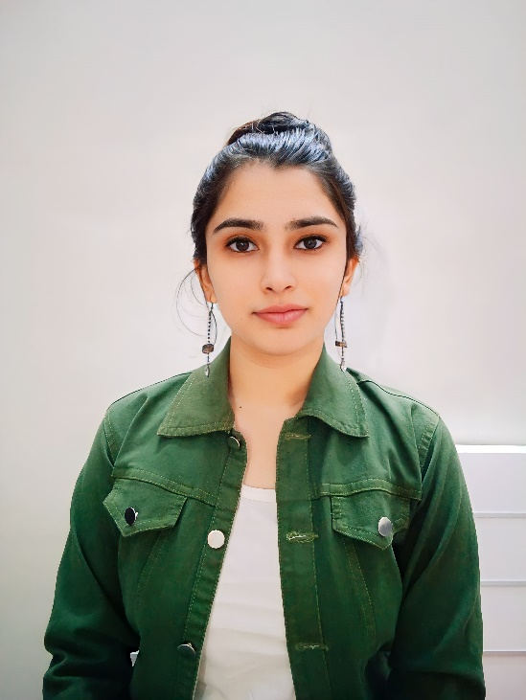
Sakshi Morgaonkar
PRESIDENT

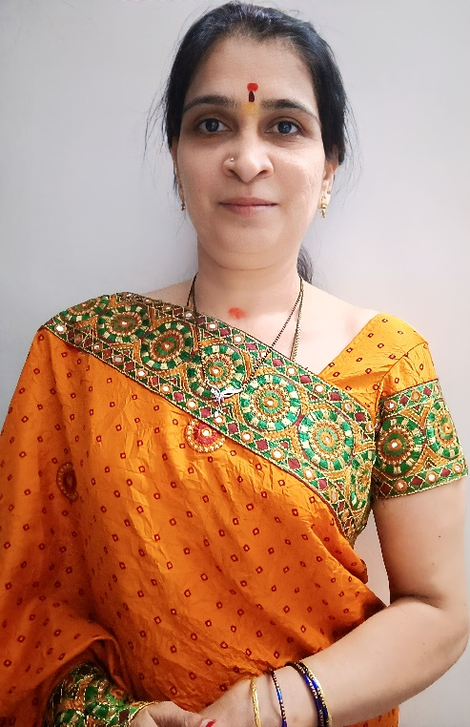
Sheetal Morgaonkar
Vice President

Shwetal Dixit
Council Member

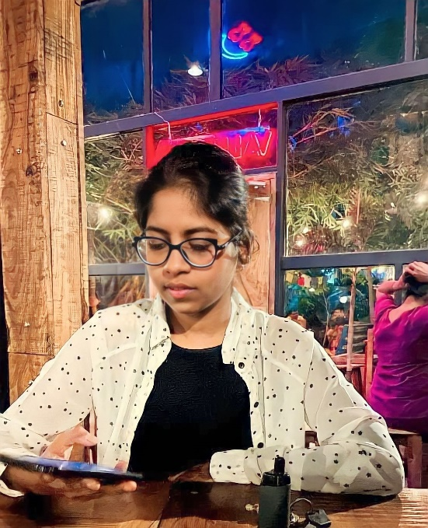
Rasica Telgote
Council Member

Loveleen Kaur
Council Member

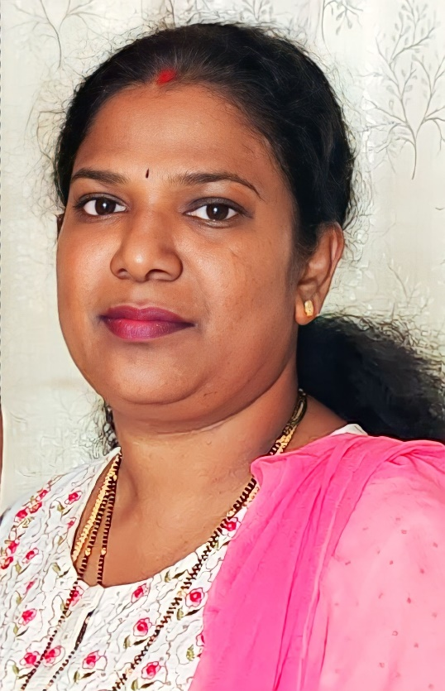
Rekha Deshpande
Council Member
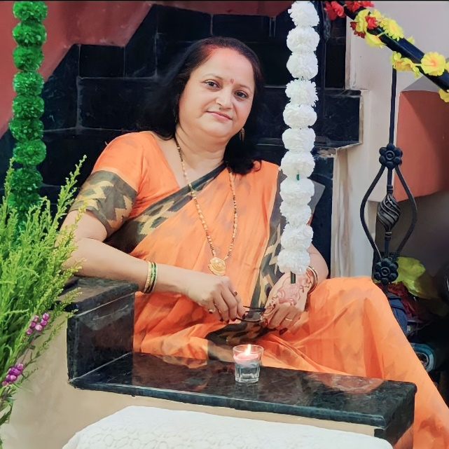
Madhuri Joshi
Council Member

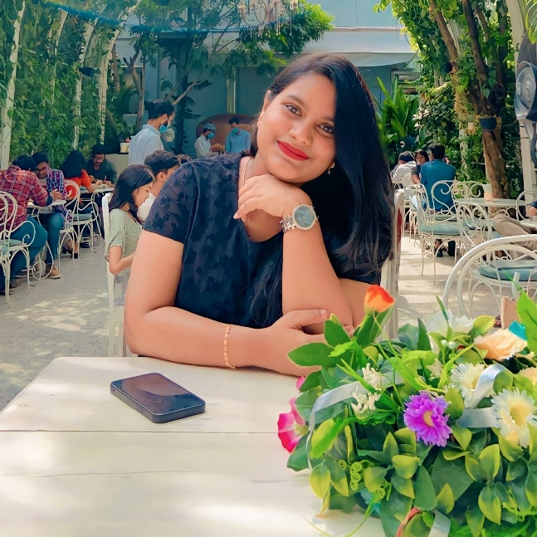
Sirisha Bonepalli
Council Member

Raja Meena R
Council Member

Chaitali Waghmare
Council Member
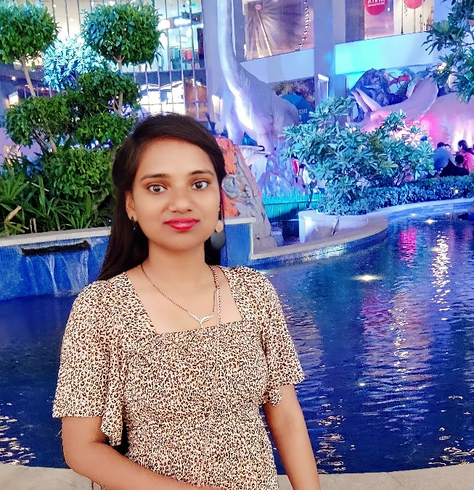
Sony Yadav
Council Member

Rishika Shukla
Council Member

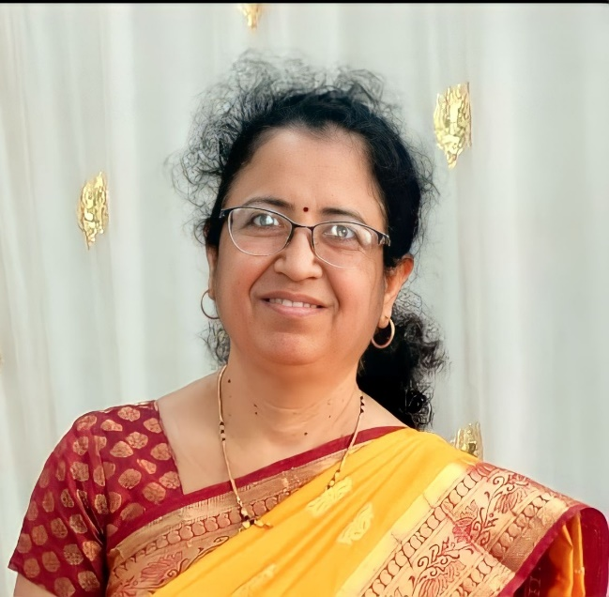
Minal Dixit
Council Member

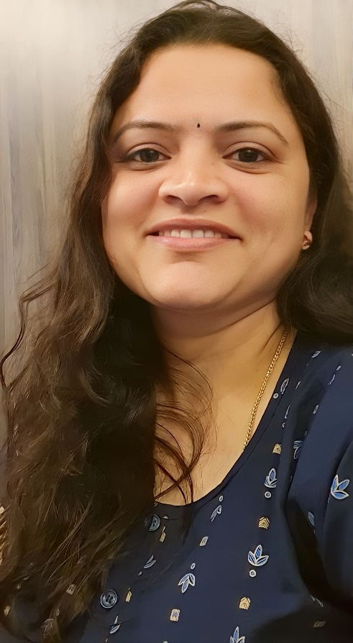
Shweta Deshpande
Council Member

